**SWE20001: Managing Software Projects**

**Team name:** Team Apple

**Member:**

•Pasan Sanjula Senanayake (103128866),

•S M Ragib Rezwan (103172423),

•Fadal Arhab Farouk (102421195),

•Mithila Minara (103128691),

•Virul Vinwath (102625159)

•Anuradha Isurindu (102423308)

**Tutor:** Naveed Ali | 12.30pm Tuesday | EN31

**Project Proposal1 : GotoGro**

1. Trello chart day 0

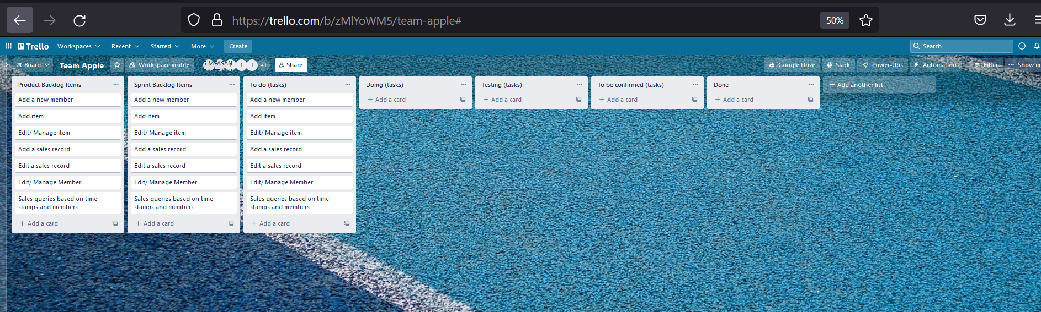

1. Github day 0
2. BurnDown chart day 0 (using excel for this instead of trello)

